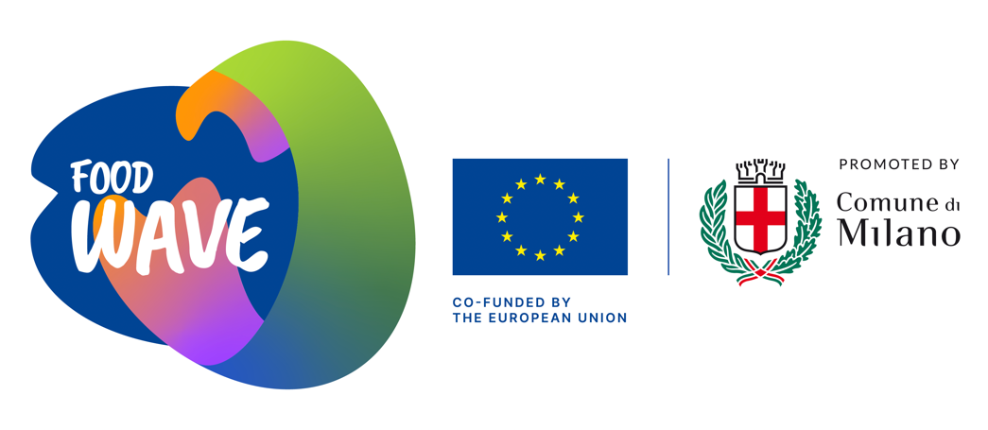

APPLICATION FORM
Every food is a landscape
—
Curated by Marco Trulli
Organized By BJCEM (www.bjcem.org) in the frame of “Food Wave - Empowering Urban Youth for Climate Action” (www.foodwave.eu), a project co-funded by the European Commission under the Development Education and Awareness Raising Programme.
(Reference number:EuropeAid/160048/DH/ACT/Multi).
Deadline for application: May 8th 2022 midnight (Italian time)

This form has to be filled in EVERY ENTRY and the validity of data is completely under your responsibility. The only accepted language is ENGLISH, no other languages will be accepted.

PERSONAL INFORMATION

This form has to be filled in EVERY ENTRY and please check that your data are written correctly (name, passport number).

NAME (as indicated in your passport)
SURNAME (as indicated in your passport)
GENDER M F OTHER (specify your chosen pronouns)
DATE OF BIRTH
PLACE OF BIRTH
NATIONALITY
ADDRESS (Place you are currently living)
COUNTRY
PASSPORT NUMBER
PASSPORT EXPIRY DATE
TELEPHONE NUMBER (specify international code)
MOBILE NUMBER (specify international code)
E-MAIL
WEBSITE (if any)

TO BE PROVIDED:

All interested applicants are asked to submit one PDF (max 6 MB) including:

- application form (this form)
- complete CV
- portfolio
- motivational letter
- a proposal of 400 words max and visual material responding to the curatorial concept concept (you could send a project already realized or a conceptual idea and the related budget to produce it)

Important additional information:
- The application can be sent ONLY via email to BJCEM at: application@bjcem.org
- The subject of the email should read: “Food Wave_Name_Surname”

PRIVACY

BJCEM aisbl, (Registered Office c/o Fidelium Boulevard Saint Michel, 65 B-1040 Bruxelles-Belgium; Executive Office Cortile del Maglio via Andreis 18 int. 18/c 10152 Turin – Italy T +39 011 19504733), informs, in compliance with art. 13 EU Regulation 2016/679 (GDPR), that will process data users collected through this form with the following modalities and for the following purposes:

- BJCEM collects the personal data of this form only for purposes related to the evaluation and selection of the participants to Food Wave project;
- Your email will be used by BJCEM Executive office and the curator just to get in touch with you, if required at any step of the evaluation process;
- BJCEM will use your name and surname only to promote the event and for its communication purpose;
- no data will be disclosed by BJCEM to third party.

Please notice that any information written in this form is considered definitive. Any further change in the technical form will not be accepted.

DATE................................... SCANNED SIGNATURE....................................................

